**AIRLINES DATA ANALYSIS**

**CHART 1: ASM & RPM COMPARISON**

(**ASM**) Available seat miles is the measure of airline capacity calculated as the total number of seats multiplied by the total distance travelled.

**RPM** (revenue passenger miles) is a number of miles traveled by paying passengers.

**ASM & RPM Comparison shows the comparison between total seats that are available and total revenue gained by tickets booked by the passenger.**

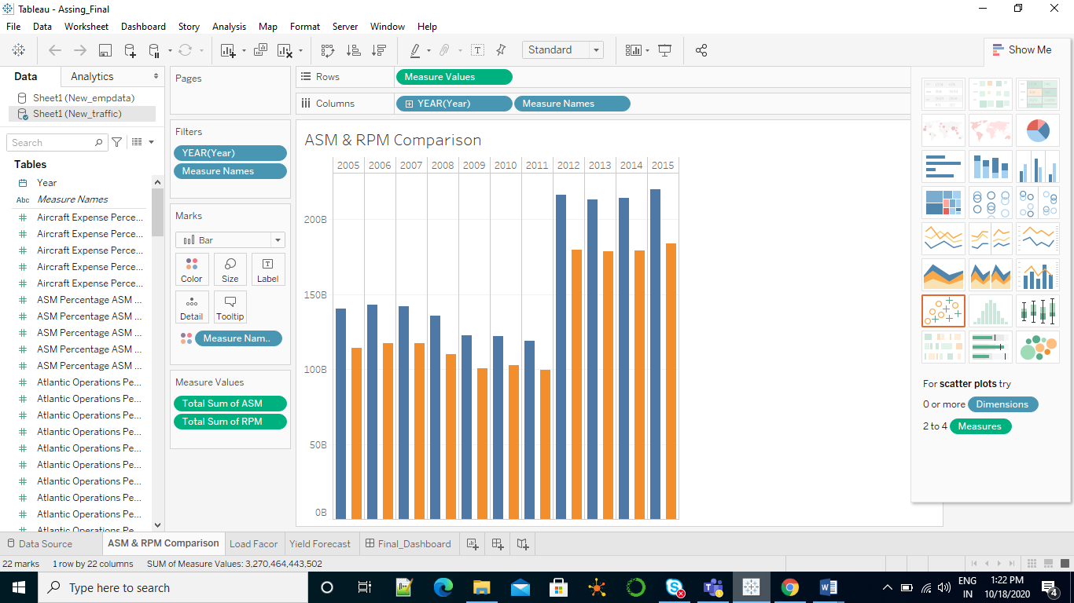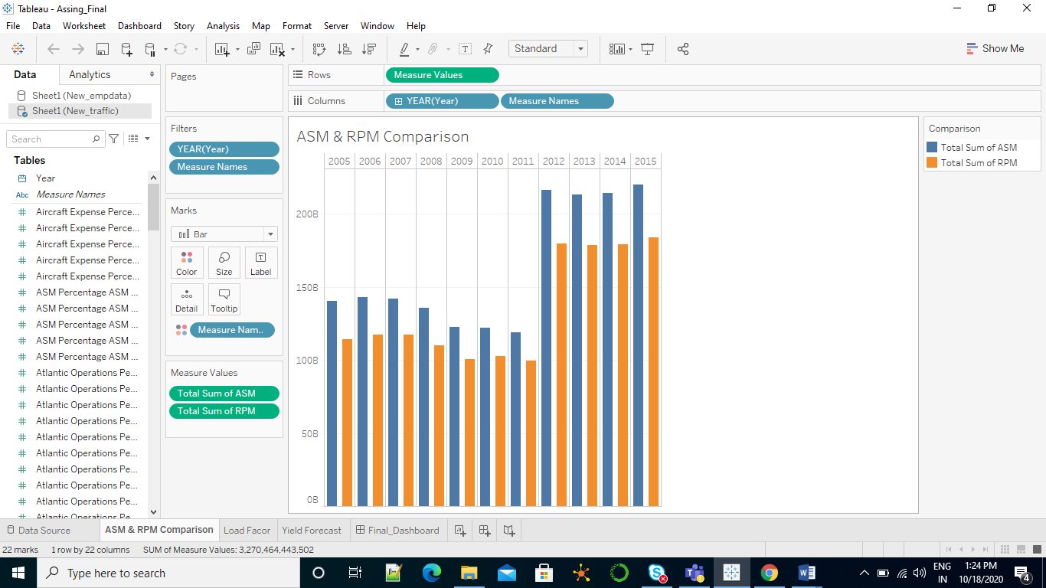

1. Which year has maximum ASM and RPM?

**Solution:** 2015

1. Which year had lowest ASM?

**Solution:** 2011

1. From the graph what can be inferred for the year 2015?

**Solution:** In year 2015 ASM and RPM is maximum when compared with other years. It can be inferred that airlines had made a good profit.

#### TYPE OF VIZUALIZATION: Side-by-Side Bar Chart

#### REASON: As Side-by-Side Bar Chart are more preferred in comparison as it provides better understanding.

#### GESTALT PRINCIPLES:

* **SIMILARITY:** Objects of the same color belong to the same group.
* **CLOSURE:**   two axes are required on a graph to define the space in which the data appears, x and y-axis.
* **PROXIMITY:**  objects close to each other belongs to the same group.

#### PRE-ATTENTIVE ATTRIBUTES:

* Color
* Length
* Width

**colour** helps to show difference between ASM and RPM

**Length, width** shows each form property can be used to call attention to a part of a visualization without conscious effort.

**CHART 2: LOAD FACTOR TREND FOR DOMESTIC AND INTERNATIONAL**

**Load factor** is an indicator that measures the percentage of available seating capacity that is filled with passengers

**This graph shows the load factor comparison between domestic and international travel**

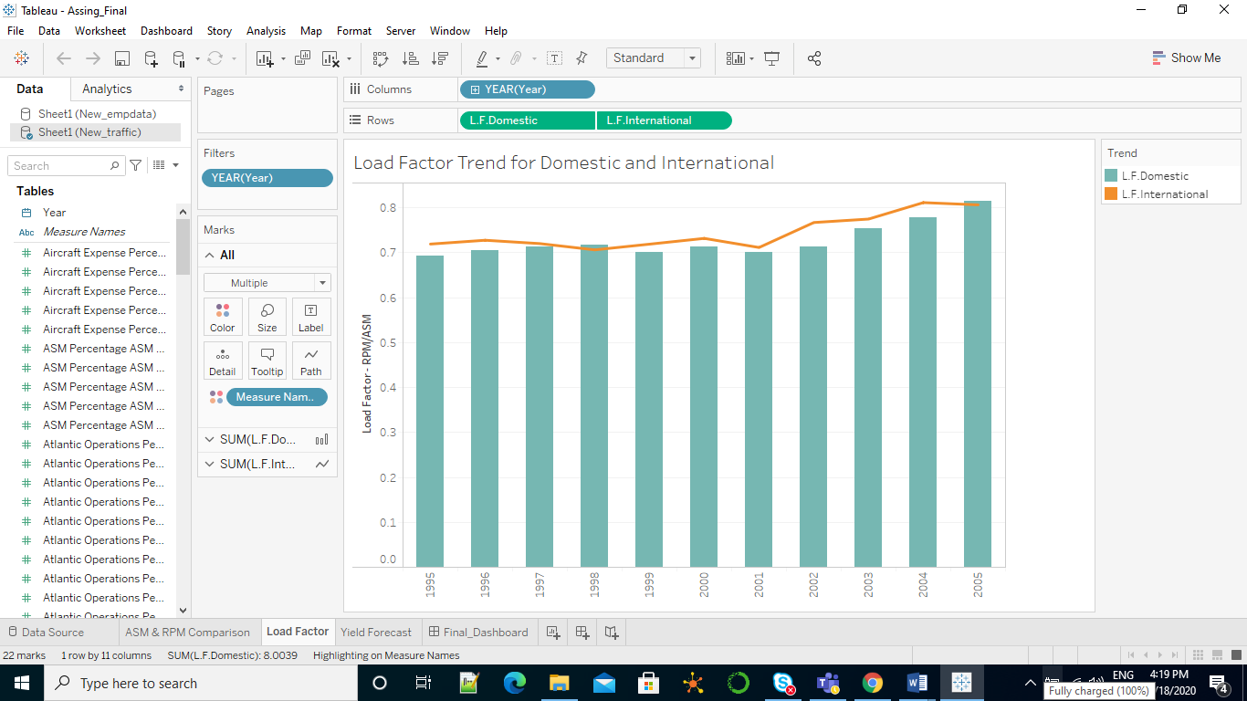

1.Which year has least difference between LF domestic and LF international?

**Solution:** 2005

2.Which year has maximum drop in LF International?

**Solution:** 1998

#### TYPE OF VIZUALIZATION: dual combination chart

#### REASON: dual combination chart helps in understanding the relationships between two variables with different magnitudes and scales of measurement. So it is easy in understanding load factor between LF domestic and LF international.

#### GESTALT PRINCIPLES:

* **SIMILARITY:** Objects of the same color belong to the same group.
* **CLOSURE:**   two axes are required on a graph to define the space in which the data appears, x and y-axis.
* **CONTINUATION:  elements** that are arranged on a line or curve are perceived to be more related than elements not on the line or curve.
* **PROXIMITY:**  objects close to each other belongs to the same group.

#### PRE-ATTENTIVE ATTRIBUTES:

* Color
* Length
* Curvature
* size

**colour** helps to show difference between ASM and RPM

**Length, width,** **Curvature, size** shows each form property can be used to call attention to a part of a visualization without conscious effort.

**CHART 3: YIELD FORECAST**

**Yield** is the average fare per passenger per mile.

**This graph shows the yield comparison over the years and also yield rate in future.**

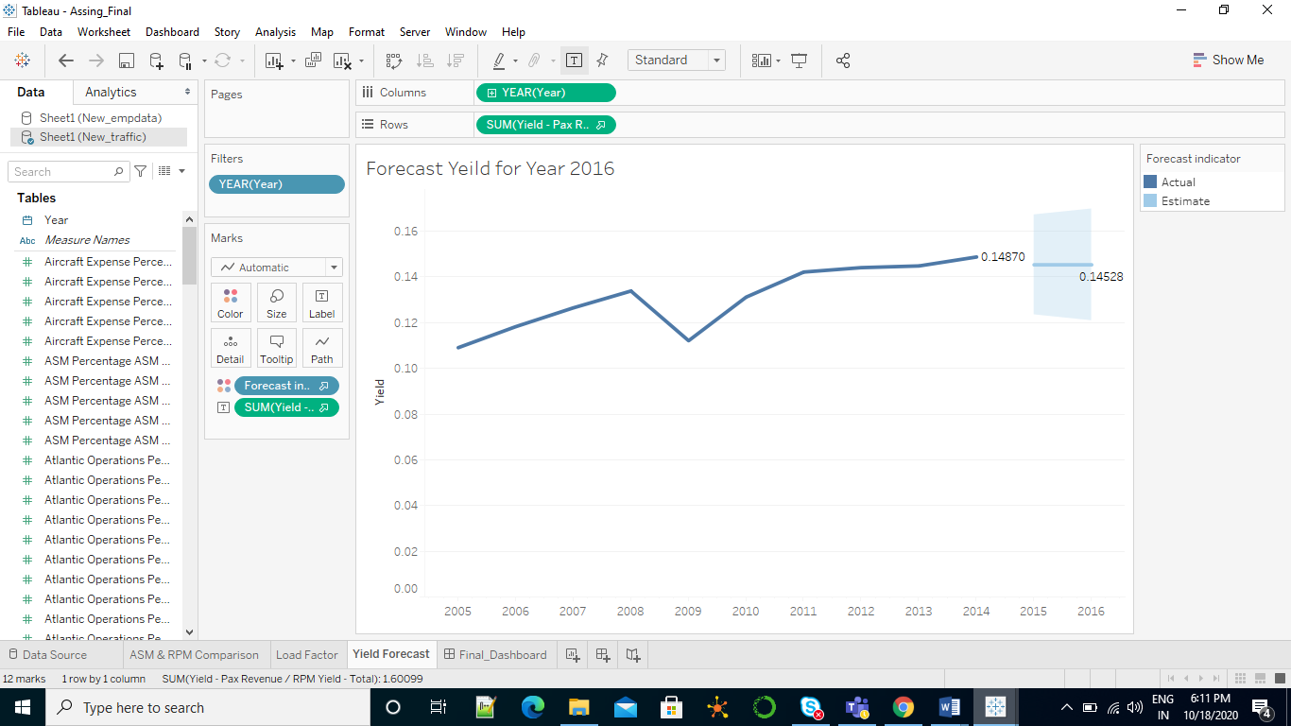

1.Which year has maximum drop in yield rate?

**Solution:** 2009

2.what is the inference in future yield rate?

**Solution:** when compared with previous quarter, decrease in yield rate is predicted in future

#### TYPE OF VIZUALIZATION: line graph

#### REASON: Line graphs can also be used to compare changes over the period of time. Hence line graph is used to show changes of yield rate over years.

#### GESTALT PRINCIPLES:

* **ENCLOSURE** A group of objects can be enclosed by anything that forms a visual border.
* **CONTINUATION:  elements** that are arranged on a line or curve are perceived to be more related than elements not on the line or curve.
* **SIMILARITY:** Objects of the same color belong to the same group.

#### PRE-ATTENTIVE ATTRIBUTES:

* Color
* Length
* Curvature
* Enclosure
* Size

**color** helps to show difference between ASM and RPM

**Length, width,** **Curvature, size, Enclosure** shows each form property can be used to call attention to a part of a visualization without conscious effort.